**INTEGRATING SENDGRID WITH PYTHON**

|  |  |
| --- | --- |
| Team ID | PNT2022TMID36311 |
| Project Name | Nutrition Assistant Application |

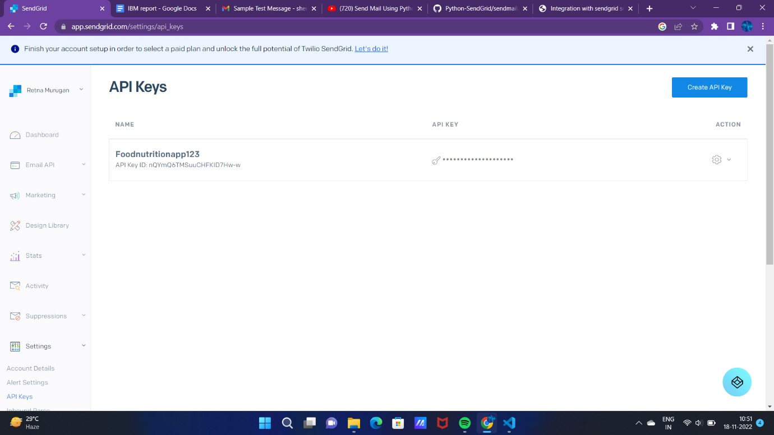

**Install package : > pip install Sendgrid**

**Send mail :**

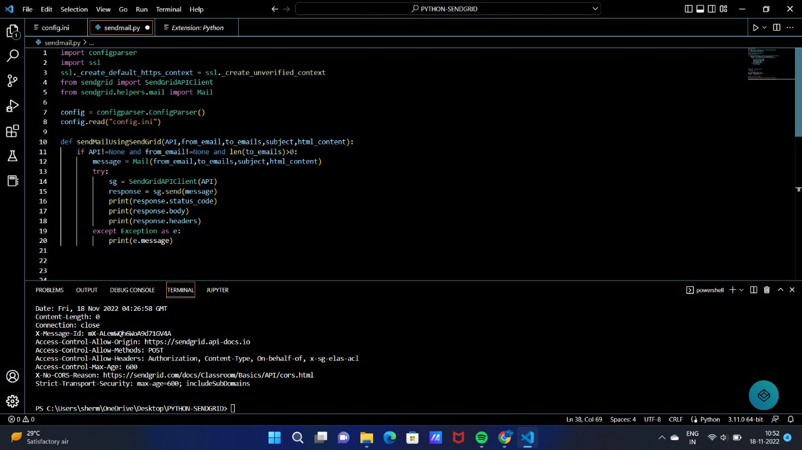

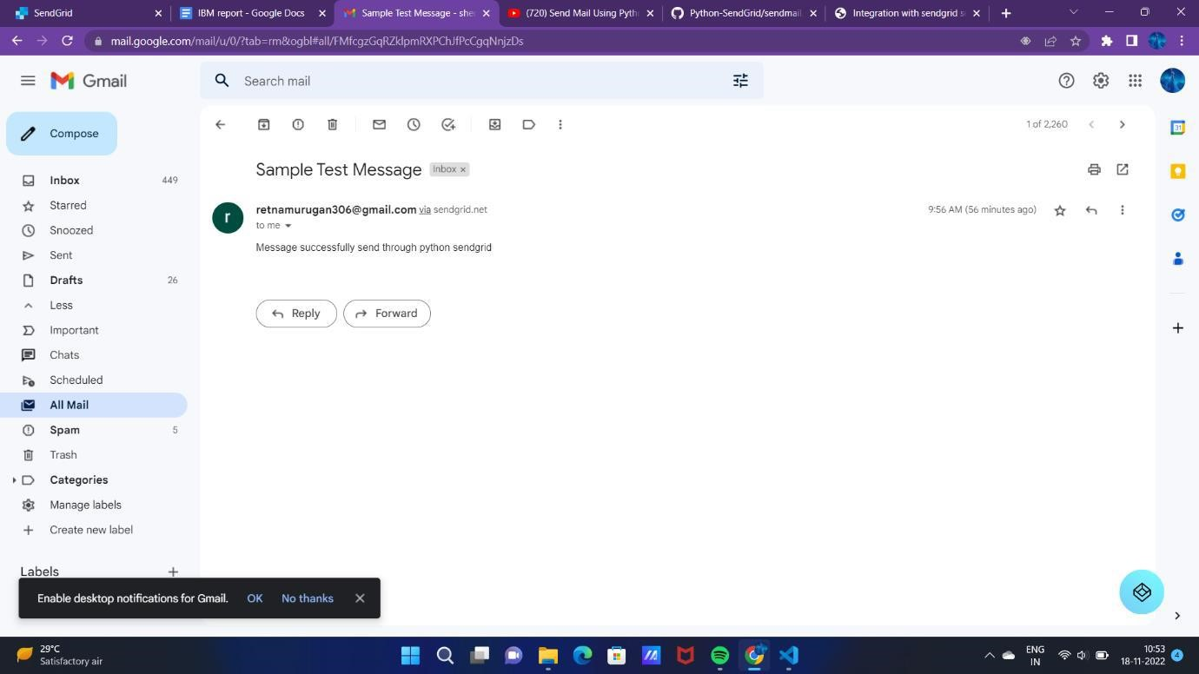

**Sendgrid mail activity :**

